2.BOOK BANK MANAGEMENT SYSTEM

ACTIVITY DIAGRAM:

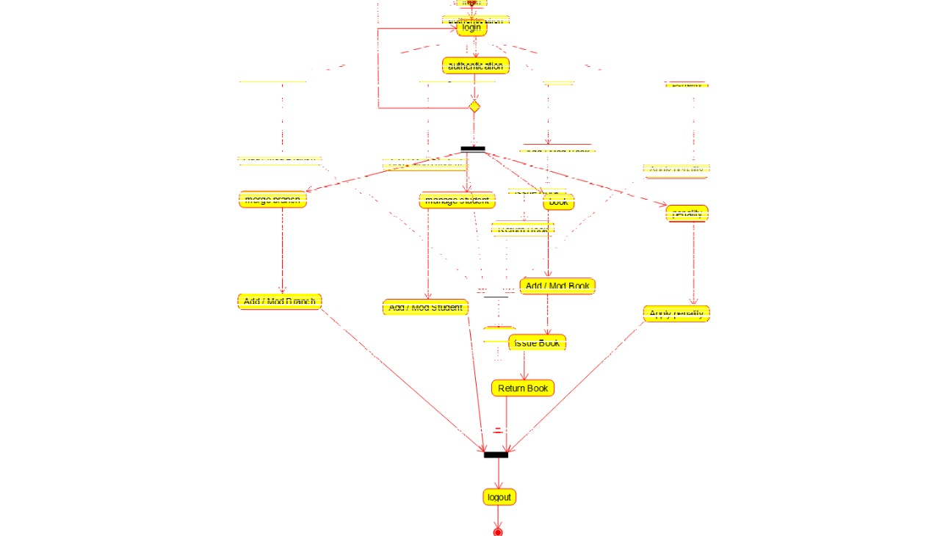

COLLABORATION DIAGRAM:

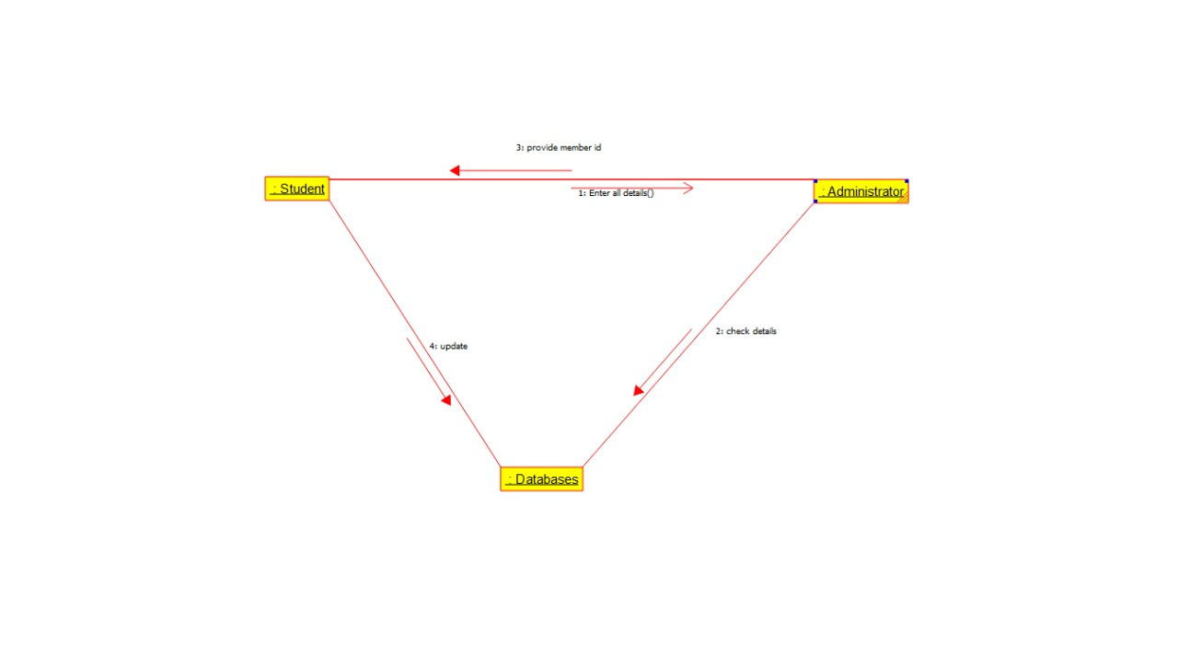

SEQUENCE DIAGRAM:

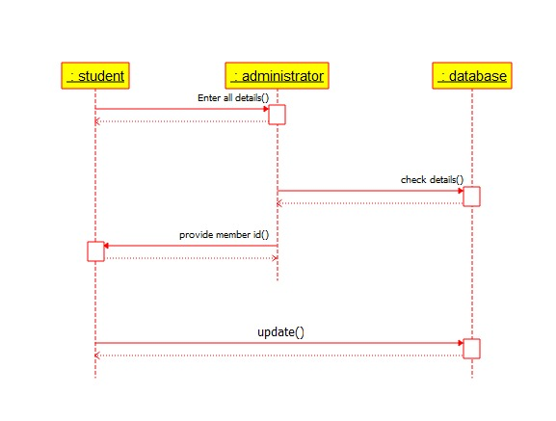

STATE DIAGRAM:

